ENG 105 Research Paper

People’s Perception on the inclusion of transgenders in the workplace in Bangladesh.

Ishtiaque Hossain Sajid

1731485630

Section- 10

North South University

Abstract

Transgenders rights have been a major issue and talk of the town around the whole world. In Bangladesh too, transgenders rights are vastly controversial. Even the general people along with the state system are divided and dilemmatic as to how exactly the Transgenders should be treated. This paper broadly researches about “*People’s Perception on the inclusion of transgenders in the workplace in Bangladesh.”* Through this research it is to be found whether people see the transgenders as a positive force or do they possess negative perspective about them and don’t want them to be working alongside them. Before the research the hypothesis was that the perception will vary with the respondents ages. The hypothesis did match to some extent with the real findings, as the more aged respondents had more conservative perception about the transgenders in the workplace. All the graduates said that they don’t see themselves as following a transgender as their superior.

Table of Contents

**Introduction** 4

**Background** 5

**Areas of Research** 8

**Hypothesis** 9

**Methodology** 9

**Data Presentation and Analysis** 11

**Primary Data Presentation** 11

**Graphs** 12

**Data Analysis** 14

**Summary of Research Findings** 20

**Conclusion** 21

**Limitations** 21

**Reference** 23

# **Introduction**

Transgender denotes to a person whose sense of personal identity and gender does not correspond with their birth sex, while cis gender refers to denoting or relating to a person whose sense of personal identity and gender corresponds with their birth sex. Here it is to be noted that sex and gender are two very different things. American Psychologist Association (APA) has said, “Sex is assigned at birth, refers to one’s biological status as either male or female, and is associated primarily with physical attributes such as chromosomes, hormone prevalence, and external and internal anatomy. Gender refers to the socially constructed roles, behaviors, activities, and attributes that a given society considers appropriate for boys and men or girls and women. These influence the ways that people act, interact, and feel about themselves. While aspects of biological sex are similar across different cultures, aspects of gender may differ.” (Para 2) Transgender may also include people who are not exclusively masculine nor feminine. It also infrequently includes cross-dressers. According to Bradford (2018), “"Transgender" is an umbrella term that describes people whose gender identity or expression does not match the sex they were assigned at birth. For example, a transgender person may identify as a woman despite having been born with male genitalia.” (Para. 1)

The focus of this research will be on how the general people actually sees the transgenders and how much willing they are to involve them in their work space. Most transgender people face discrimination in the workplace and in accessing public accommodations, and healthcare. Though in 2013 transgenders have been lawed into a separate gender and also have been invited to apply for government jobs there have been no reports of one actually being recruited. The social attitude towards transsexual people in Bangladesh is said to be very hostile being a Muslim majority country, though recently many advertisements and voices has been raised in support of them and to arrange for their rehabilitation. But it is a matter of investigation as to what general people would feel and react to sharing spaces with them.

# **Background**

As mentioned before, transgenders are called “Hijra” in Bangladesh. This term is not very clear as to whom are actually denoted by it. The intersex people as well as the transgenders are called Hijras by the normal people. Even the lesbians and gays are many a times called as hijra. Furthermore, people are not clear as to why or what causes people to be transgenders.

After a transgender expresses him/herself as one, s/he becomes a social outcast. In an article published in Dhaka Tribune by Ms. Bilkis Irani (2018) titled, “Life as a transgender child in Bangladesh” the life story of a 14-year-old transgender has been talked about. Though the subject was born as a boy, introduced as a boy to everyone by the family, she wanted to be a girl. And when she announced herself as a transgender, she became a social outcast. Her family started to torcher her. She was even denied from admitting into any schools. Even when she fell ill, she would not be taken to any doctors. Her father wished by saying in front of her that he would wish that she would just die. And at the age of seven she had to leave home. Even after leaving home she was constantly abused at every walk of life. She suffered vigorous sexual harassment. People used to force her to have physical relations, some offered her money like 500-1000 taka. And as she was a social outcast and cannot speak out people took advantages of her. The girl did not even know of the sexual diseases and AIDS. After knowing about it too she could not be sure if she had any of these diseases because the doctors there will not even touch her let alone conduct tests. Like this girl, this is the case for most of the transgenders. They are deprived of the basic rights and hated by their own family.

It is reported that there are approximately 10000-15000 transgenders living in Bangladesh as per some independent NGO’s the number is around half a million. To the general people transgenders are known for racketeering only. Many of them look towards the transgenders with hatred. In 2013 the ministry cabinet passed the law citing “Hijras” or Transgender as the 3rd gender. Through this declaration by law the transgenders gained the right to all other men or women in the country. The passport as well as the National Id card has a separate column for the 3rd gender. But in reality, did the transgenders really enjoy all human rights? Do they even get the opportunity to attain an employment and earn their living like normal men or women?

While Bangladesh has passed legislation to protect Hijra’s rights, the government simultaneously continues to uphold laws that punish citizens for being homosexuals (Though Hijras do not always identify as homosexuals, they are sometimes persecuted as such) with prison sentences ranging from 10 years to life. Article 377A of the Bangladesh Criminal Penal Code provides: “Whoever has carnal intercourse against the order of nature with any man, woman or animal, shall be punished with (imprisonment for life), or with imprisonment of either description for a term which may extend to ten years, and shall also be liable to fine”. No hate crime law exists in Bangladesh to address crimes committed by a perpetrator motivated by the sexual orientation or gender identity of a victim. Bangladesh has no anti discriminatory laws that specifically protect sexual minorities or laws that recognize the diverse gender identity. (Jebin & Farhana, 2015, para “Legal status of hijra community in Bangladesh”)

Though Hijras traditionally earned their living by singing and dancing, many now supplement their earnings by begging or selling sex (Nag, 2005). A study on Bangladeshi Hijras describes the vulnerability of sex workers to law enforcement abuses: The Hijra sex workers were exploited by clients, mugged, and beaten by hooligans but never received any police support. They hardly reported any incidents to police because of fear of further harassments. The law enforcing agents either raped a hijra sex worker and/or burglarized earnings from sex trade… hijra are not safe in sex trade. They are forced to have unprotected sex with clients, local influential persons, and police free of charge (Khan, Hussain, & Parveen, 2009).

Recently on the month of July Tanisha Yeasmin Chaity became the 1st transgender to get employed in a government organization. She was appointed as a front desk executive at the National Human Rights Commission (NHRC). There is an industry named “Logos” in panthapath which is said to have employed 32 transgender people. Gono University has recruited transgenders as security guards. These are very few people compared to the population that currently prevails. Furthermore, all these are the cases of 2018. Question arises why are the numbers so low? What do the normal people think about it?

Transgenders in Bangladesh are often deprived of basic education. As many of them has mentioned their family themselves are not supportive of them and don’t want them to be around them, parents don’t even send their transgender kids to school as people raises many questions about those kids. There is also a social stigma that Transgenders are born due to any sins of the previous life. Through the law transgenders can avail free primary education like all other people. But very few of them do avail this opportunity and has gone to build a career or earn an esteemed livelihood. Why does the others do not walk the same path? Is it because of the social hostility they face from their classmates? Or is it because they are reluctant to go, lack the will power and thinks that racketeering or extortion is much easier than the normal jobs or employment?

# **Areas of Research**

As per the background of my research, four questions arose which acted as the driving force or the area of the research. The questionnaire and subsequent research were designed and conducted to find those answers.

**Peoples’ view on those who does not correspond to their birth sex**

To know about peoples’ perception on transgender being involved in work alongside them it is first necessary to know what people think actually transgender is. Why do they think one becomes transgender? Do they have the notion that transgenders and intersex is same? Or even the lesbians and gays all are termed as transgender? This question clears out if the respondents are biased. Also, if the respondents are affected by any social stigma that will be cleared out. This will act as the 1st step instant perception towards transgenders by the respondents.

**How much close will the respondents be with the transgenders?**

This is to further clear out the perception of the respondents towards transgender in general. Do they feel comfortable or do they want to avoid the company of transgenders? If they claim they see the transgenders as same human beings as them then how much close are they willing to be with them.

**How will they treat trans co-workers?**

If a transgender is working beside the respondents, then what will be their attitude towards them. Will they value the trans co-worker as equal to other normal co-workers? Are they willing to be friend with the trans colleagues? Which way will the benefit of doubt go if it is between a transgender and a male/female person?

**What amount of responsibility and authority does the transgenders deserve in the work place?**

This will further reveal peoples’ perception towards transgenders people establishing a career. Now, many may accept transgender people earning a decent living, but are they ready to give them all the opportunities there is. Will they work in an office which has a transgender people as their superior? Will they entrust any transgender with one of the most important roles within an organization?

# **Hypothesis**

Transgenders are still considered out of the society members in Bangladesh. From this research it is expected that peoples view on transgenders will vary in par with ages. The elderly will be against the transsexuals being involved in the society whereas the young generations will be much liberal and willing to work and socialize with them. But as norms of trans people being involved in respectable jobs is new in Bangladesh it is expected that even the young generations will feel uneasy to take orders from them. It can also be assumed that a part of the participants will express that the laws of Bangladesh regarding transgenders rights and protections from discrimination are vague and insufficient.

# **Methodology**

For the primary research, a survey will be conducted on a representative sampling of the general public in Bangladesh, and people who actually worked or contacted with transgender people will be contacted to find out actual insights and experiences. To that end, a questionnaire with different types of questions will be designed so as to get a range of useful data which will help to answer the research questions. My questionnaire had a total of 13 questions of which 12 was close ended and one open ended. It was designed in such a way that through these the research questions can be answered and analyzed, and the research can act as a sample of the population as the respondents were random. A total of 34 respondents filled in the questionnaire.

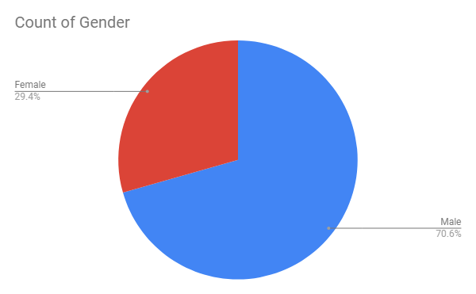

Out of the 34 participants 10 were female while 24 were male.

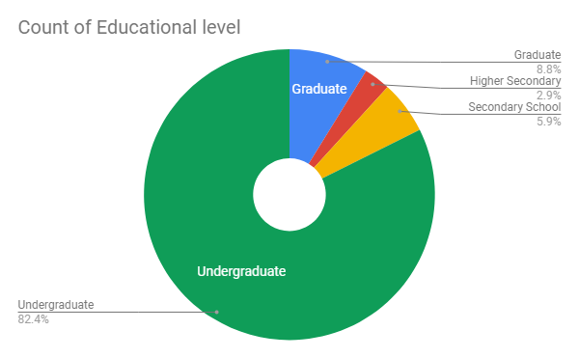

And 28 of the respondents were undergraduate students, 3 were graduates and 3 were school goers.

For the secondary research, the sources of the library like articles and autobiographies about transgenders will be used. The internet will also be browsed and standard search engines like Google will be used. The purpose of the secondary research was to acquire a clear idea of the situation of the transgenders around the country also get ideas of the previous research conducted regarding it.

# **Data Presentation and Analysis**

## **Primary Data Presentation**

The primary data was the survey conducted through the questionnaires. A total of 34 respondents participated in the survey.

|  |  |  |  |  |  |
| --- | --- | --- | --- | --- | --- |
|  | A | B | C | D | E |
| 1.Why do you think transgenders people are born? | 85.3% | 2.9% | 0 | 11.8% |  |
| 2. Did you ever talk with any transgender? | 41.2% | 58.8% |  |  |  |
| 3. If given the chance, would you like to talk with one? | 94.1% | 5.9% |  |  |  |
| 4. Will you share any personal stories with any transgender given that you know him/her for some time and is trustworthy? | 76.5% | 23.5% |  |  |  |
| 5. Do you see yourself following a transgender as your superior? | 67.6% | 32.4% |  |  |  |
| 6. If any transgender is your sub-ordinate, how would you treat them? | 67.6% | 2.9% | 29.4% |  |  |
| 7. How much qualification do you think a transgender need to reach in your current work position? | 67.6% | 11.8% | 20.6% |  |  |
| 8. Do you think transgenders needs more opportunities to join the regular jobs? | 23.5% | 76.5% |  |  |  |
| 9. Will you ever share an apartment with a transgender? | 76.5% | 23.5% |  |  |  |
| 10. Why do you think transgender people don’t enter into studies and works like everybody else? | 79.4% | 5.9% | 14.7% |  |  |
| 11. Will you take the risk of referring transgenders for employment/ grants/ studies to your superior, provided that they have potential? | 94.1% | 5.9% |  |  |  |
| 12. If you find a transgender involved in conflict with a co-worker, what role will you play? | 21.2% | 6.1% | 60.6% | 0 | 12.1% |

## **Graphs**

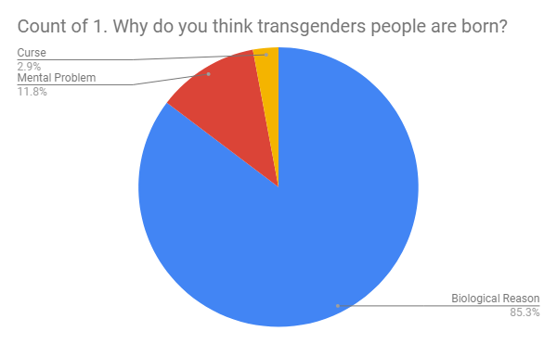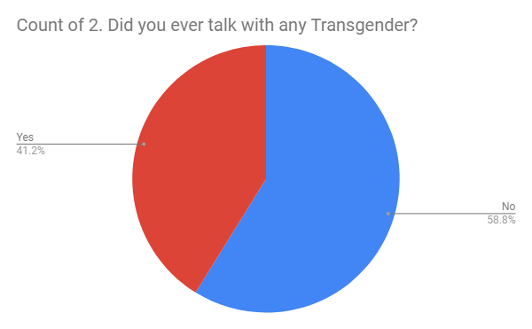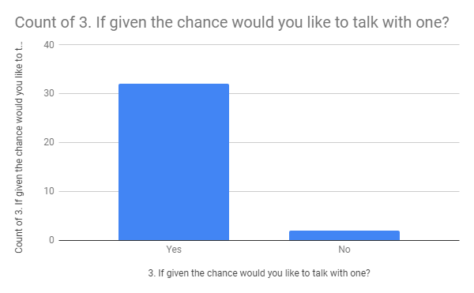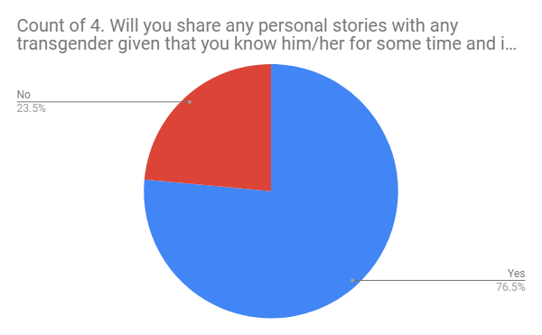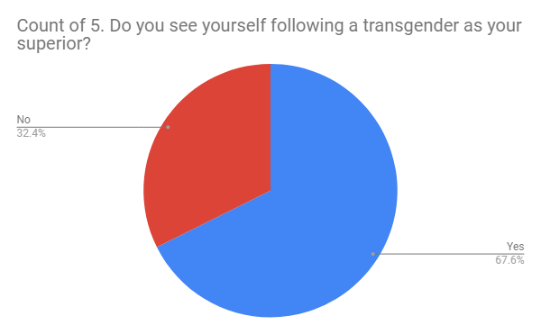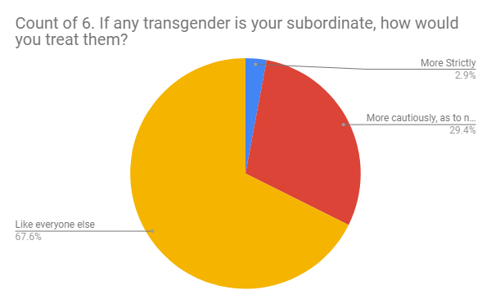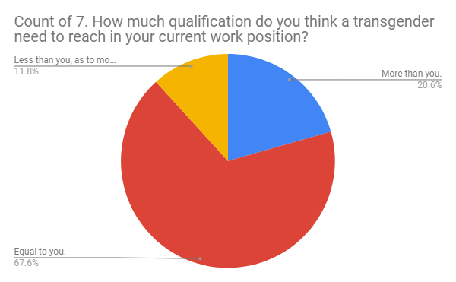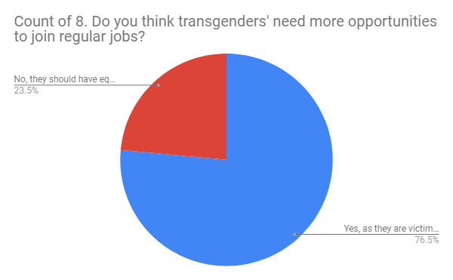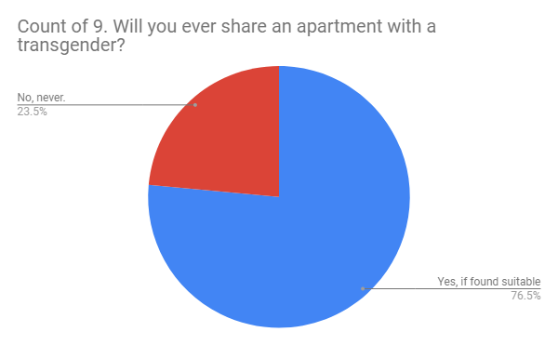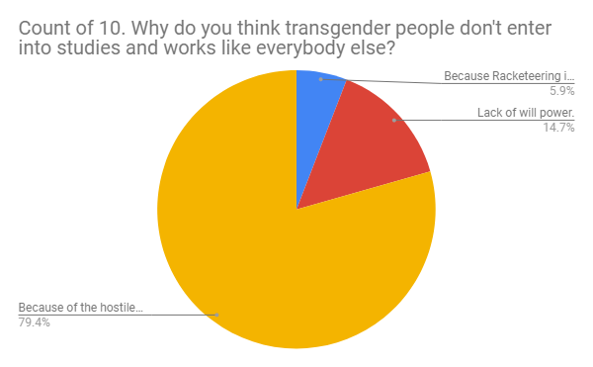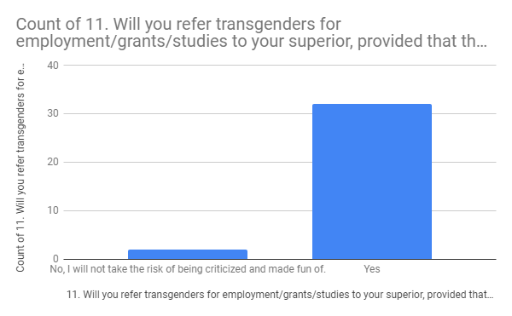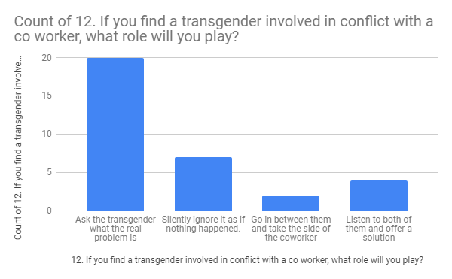

## **Data Analysis**

The first question was why do the respondents think transgenders are born. 85.3% of the respondents think that it is for biological reason. 2.9% of them thought it happens due to curses. And 11.8% think that transgenders is actually a mental problem. Now this gives an idea if the respondents are biased or not. The ones who thought it is due to curses must possess negative perception about the transgender people. Biological problem means they were born in this way and so they are due to the act of nature. It is unclear though if these participants have mixed transgenders and intersex altogether.

Secondly, 58.8% of participants said they have not talked to any transgenders yet while 41.2% have already interacted with them. This means 41.2% have first hand knowledge about the transgenders, they are more open to them and most likely possess positive perception. Though it might also happen that the interaction that happens while being racketeered by the transgenders has been deemed as talking or interaction to the responders.

31 of the participants expressed that they would like to talk with transgenders people while 2 of them said they are not willing to talk with them. These 2 might be affected from comfort zone problem or maybe they have any bad experiences with the transgenders and so want to avoid them altogether. The 31 positive responders are comparatively more open and accepting of the transgenders.

The 4th question was if the responders will share personal stories with any transgenders, provided that s/he knows the transgender for some time. 76.5% of participants said yes, they would share. But 23.5% said they would not. This question was to find out how close the respondents are willing to go with the transgenders. 76.5% are willing to go to personal level communication with them.

Then the respondents were asked if they see themselves following a transgender as their superior. 67.6% participants said yes, they do see themselves. This means 67.6% of people really do hope good for the transgenders and sees them doing good in the future. Also, that these people are willing to work under a transgender. But 32.4% said they do not see themselves as following a transgender. This means they are more likely reluctant to see the transgenders do good in the future and establish themselves as leader in the future. It is also very likely that this 32.4% will not take any transgender as their superior officer.

Proceeding further, the respondents were asked if they had a transgender as their subordinate how would they treat them. The options were a) like everybody else b) More strictly c) More cautiously, as to not hurt their feelings. The answers were mixed. But the majority of 67.6% respondents said they would treat their subordinate transgenders as like everybody else. 29.4% of them said they would treat the transgender subordinates more cautiously so that they are not hurt by any means. But 2.9% said they would treat the transgenders more strictly. Maybe they have negative perception towards them, think they will be less disciplined and so needs more monitoring to get jobs done.

Next up, the participants were asked how much qualifications do they think the transgenders need to reach in their current position. 67.6% opined that the transgender should also have the same qualification as them. 20.6% said they think the transgenders need more qualifications than them to reach in their position. And 11.8% expressed that they think transgenders should need less qualifications than them so that they are in all motivated to follow an established career path. Most people are okay with equality i.e. sharing both responsibility and authority, but what many fears is that by trying to establish equal rights will the other party take unfair advantages of it and at the end of the day will they themselves lose their own opportunities!

In this step, participants were asked if they think transgenders people need more opportunities to join regular jobs. Here 76.5% said that the transgenders do need more opportunities as they are victims of social stigma. The other 23.5% said that the transgenders should not have more opportunities but should have equal opportunities as like others. Now they might fear if more opportunities are given then the normal people or the participants themselves might face a threat in finding jobs. The positive 76.5% may feel compassionate towards the transgenders and want to see them flourish, they might also hate the social stigmas the transgenders have to face so they are welcoming and ready to give more opportunities for the transgenders. In overall perspective employment of transgenders is altogether new in Bangladesh. Employers might fear of an unstable environment because of them and would try to avoid employing them. Again, recently many companies are taking initiatives of employing transgenders along with the Government which is acting as a good PR, this might provoke employers to give the transgenders a chance at employment.

The next question was more on a deeper level and in aspect of personal level. Will the respondents ever share an apartment with a transgender? 23.5% respondents said they would never share do it. While the other 76.5% respondents said they will share an apartment with a transgender if found suitable. For study and work purpose many has to stay bachelor or by sharing an apartment with other people. Transgenders may need it too. And the question is as they are minority will they get this chance? 76.5% people said they will give them this chance. Now in case of the negative repliers this may not be that they would not just share it with transgender maybe they would not feel comfortable with people of other sexes, and they are not just stereotyping the transgenders.

In the next question the respondents were asked to express their opinion as to why they think transgenders do not enter into studies and works like everybody else. A 79.4% of the people said that they think it is because of the hostile environment around the transgenders they don’t get the courage and energy to go to school or apply for any normal works. 5.9% said they think it is because racketeering is easier and profitable compared to normal works. Through regular extortion and racketeering some transgenders raises a lot of money and thus their incentives of joining normal works is very low. 14.7% of the people think it is due to their lack of will power. That is, they think the transgenders themselves do not have enough will to lead a normal life. Majority here thinks that if the society would be welcoming towards the transgenders, behaved with them good and accept them as normal human beings then the transgenders would study and do normal jobs like everybody else.

In the 11th question respondents were asked if they will take the risk and refer any transgenders to the superior for employment, grant or studies. 94.1% of the participants said they are willing to take the risk and will refer a transgender to the superior for jobs, studies and even grants. But 5.9% said that they will not take the risk as it may result in them being ridiculed and criticized. It is a very good sign, as in todays world reference is what you may need the most to get a shot at something, to get an opportunity.

The last close ended question was, if the respondents find a transgender involved in a conflict with his/her co-worker what role will the respondents play. 5 options were given to them, a) silently ignore as if nothing happened. b) Go in between them and take the side of the co-worker. c) Ask the transgender what the real problem is. d) Shoot video of the conflict and post it on social media. e) Listen to both of them and offer a solution. Among the respondents 60.6% chose option C. That is, they will ask the transgender what the problem really is. 12.1% chose option e. They said they will listen to both of them and offer a solution. 21.2% said they will just ignore the situation in all as if nothing happened. Maybe they want to skip being in a controversial situation overall. And only 6.1% of the respondents said they will go in between the conflict and will take the side of the co-worker.

The open-ended question was, asking the respondents to share their insights on the issue and provide justifications/logic behind their answers. Almost all of them said they are very compassionate about the transgenders and that the transgenders should be allowed all equal rights like rest of the males and females. Some of the responses were:

“Taking the social stigma in consideration a transgender might be harrased in the workplace. In such case i would listen to the victim's side of the story first.”

“They are also human being like us and they should be treated normally. And I won't share an apartment with a transgender just as I won't be comfortable sharing an apartment with a male. There is no hate issues.”

“Hmm Personally I can't be comfortable around them but i will treat them Equally and see them Equally.If they truly deserve what they want to seek I will support them but if they use their transgender problem as an excuse to get more benefit i can't tolerate it.”

“Actually to me transgender are also humans just like us...they behave so because of the mental disorder mostly again there is a chance of his gene being that type...i guess we should help them the most we can and also treat them normally and help them getting out of such mental sickness”

“It's quite uncomfortable to live and share things with them though having a feeling that they should be equally treated.”

“Transgenders are also like us, a human being. Just because they were born like this, doesn't mean they are to be ignored or criticized. Unlike the others seen on streets, there are many transgenders who are very nice as a person, born in a respectful family.”

“I dont see them differently if they are educated (not institutional education, more like manners and behaviors) enough.”

# **Summary of Research Findings**

First of all, a research based on 34 people can not actually represent the situation and perception of the whole Bangladesh. But within this people the research generated positive results. In all the questions majority chose the answer favoring the transgenders.

Most people think that the people who does not correspond to their birth sex i.e. transgenders actually face biological problem. Again almost 60% of them have not talked with any transgenders so it I fully based on assumption.

In case of closeness too, majority said they are willing to be close with the transgenders. 94% said they are interested in talking and having a chat with the transgender people. 76% said they are even willing to share personal stories with them and even share the same apartment.

Almost 97% said that they will treat their trans coworkers equal to everyone else or more cautiously than everyone else. And in conflict too 60% said they will hear from the transgender person first rather than the male or female colleague.

To answer the 4th research question, 67% said they do look themselves working under a transgender and they are willing to do so.

Now it is to be seen which groups gave which answer to get a whole idea of the survey and perceptions based on age, education groups. Among the respondents, all the graduates said that they do not see themselves following a transgender. They think the transgenders should not receive extra benefits of requiring less qualifications than them. And furthermore, if they find a transgender in conflict with a coworker, 66.7% of them said they will just ignore the situation as if nothing happened, the rest said they will ask both the coworker and transgender person to resolve the situation.

The research findings do partly agree with the research findings. I assumed that the findings will vary with ages, and the graduates i.e. people over 25 are seen reluctant to follow a transgender superior. All of them have also said they will not favor the transgender more, though will offer equal rights. Through the open-ended questions and opportunity available questions too respondents said they feel the rights and laws available for the transgenders are not good enough. But in the case of “even younger generation will feel uneasy to take orders from the transgender” has been proven wrong, as they opined, they are willing to follow a superior transgender.

# **Conclusion**

This research indicates that the modern people of the society are very much aware about the status of transgenders. They do not express hatred towards them rather are willing to offer open arms to them so that they can avail their equal rights. Though the opinions of slightly older age groups vary somewhat, even they want to give opportunities to the transgenders to avail education and earning a normal living. Majority of the responders feel if the social stigma around them can be broken then transgenders too can establish a respectable position in the society. It is hopeful that as the perception is becoming more and more positive, transgenders will start to be involved within the society, they will start to apply for jobs, be interested in higher studies. The exploitation that goes on around them in the root level must be stopped through Governments initiative and the modern youth should also step up to help the transgenders however they can.

# **Limitations**

Resources were very few, so extensive research could not be conducted. Exact secondary data could not be collected as dedicated independent data collectors on this field are not available.

Due to time constraints, transgenders could not be contacted for their own opinion. Perspective of the root people can only be known by extensive field research. Unfortunately, that could not be done.

People from all ages and profession needs to be surveyed for generating sample representing whole country, but the respondents were in the age group of 17-35.

# **Reference**

Bradford, A. (2018, June 17). Transgender meaning [ Supplemental material]. What does ‘Transgender’ mean? Retrieved from: [https://www.livescience.com/54949 transgender-definition.html](https://www.livescience.com/54949%09transgender-definition.html)

Answers to Your Questions About Transgender People, Gender Identity, and Gender Expression. (ND) Retrieved from <https://www.apa.org/topics/lgbt/transgender.aspx>

Mortada, S. (2013). The third gender. Retrieved from <https://www.dhakatribune.com/uncategorized/2013/11/16/the-third-gender>

Jebin, L., & Farhana, U. (2015). The Rights of Hijras in Bangladesh: An Overview. Retrieved from [https://www.researchgate.net/publication/322753151_The_Rights_of_Hijras_in_Ban ladesh_An_Overview](https://www.researchgate.net/publication/322753151_The_Rights_of_Hijras_in_Ban%09ladesh_An_Overview)

Irani, B. (2018). Life as a transgender child in Bangladesh. Retrieved from [https://www.dhakatribune.com/feature/people-feature/2018/10/28/life-as-a transgender-child-in bangladesh?fbclid=IwAR2MJFGaO9CgB3rPNToE7elBRMTLgLyGKbjddFFdR2X NDGHHxV9U4hkYIYA](https://www.dhakatribune.com/feature/people-feature/2018/10/28/life-as-a%09transgender-child-in%09bangladesh?fbclid=IwAR2MJFGaO9CgB3rPNToE7elBRMTLgLyGKbjddFFdR2X%09NDGHHxV9U4hkYIYA)

Antara, N. (2018). Meet Chaity – the first transgender employee at Bangladesh Nat'l Human Rights Commission. Retrieved from [https://www.dhakatribune.com/opinion/special/2018/09/16/meet-chaity-the-first transgender-employee-at-a-bangladeshi-human-rights-org](https://www.dhakatribune.com/opinion/special/2018/09/16/meet-chaity-the-first%09transgender-employee-at-a-bangladeshi-human-rights-org)

Mirdha, R. (2018). Denim maker blazes a trail. Retrieved from <https://www.thedailystar.net/business/news/denim-maker-blazes-trail-1640599?amp>

Irani, B. (2018). Small factory offers big changes for transgender people. Retrieved from [https://www.dhakatribune.com/bangladesh/development/2018/07/16/small-factory offers-big-changes-for-transgender people?fbclid=IwAR3TbkES_7qbf6tiv9oag9NGmLsnT_bldue3z evIfKBe8tpdW4SuVcqCk](https://www.dhakatribune.com/bangladesh/development/2018/07/16/small-factory%09offers-big-changes-for-transgender%09people?fbclid=IwAR3TbkES_7qbf6tiv9oag9NGmLsnT_bldue3z%09evIfKBe8tpdW4SuVcqCk)